

Windows Workflow Foundation

Hands-On Lab

Lab Manual
Lab 06 – Workflows and Web Services in Visual Basic 2005

Converted from C# to Visual Basic.NET courtesy of:

Serge Luca – MVP – serge@u2u.be
U2U Training and Consultancy Services is a Microsoft .NET competence center located in Belgium, to learn more please visit www.u2u.be
Information in this document, including URL and other Internet Web site references, is subject to change without notice. This document supports a preliminary release of software that may be changed substantially prior to final commercial release, and is the proprietary information of Microsoft Corporation.

This document is for informational purposes only. MICROSOFT MAKES NO WARRANTIES, EITHER EXPRESS OR IMPLIED, AS TO THE INFORMATION IN THIS DOCUMENT.

The entire risk of the use or the results from the use of this document remains with the user. Complying with all applicable copyright laws is the responsibility of the user. Without limiting the rights under copyright, no part of this document may be reproduced, stored in or introduced into a retrieval system, or transmitted in any form or by any means (electronic, mechanical, photocopying, recording, or otherwise), or for any purpose, without the express written permission of Microsoft Corporation.

Microsoft may have patents, patent applications, trademarks, copyrights, or other intellectual property rights covering subject matter in this document. Except as expressly provided in any written license agreement from Microsoft, the furnishing of this document does not give you any license to these patents, trademarks, copyrights, or other intellectual property.

Unless otherwise noted, the example companies, organizations, products, domain names, e-mail addresses, logos, people, places and events depicted herein are fictitious, and no association with any real company, organization, product, domain name, email address, logo, person, place or event is intended or should be inferred.

© 2007 Microsoft Corporation. All rights reserved.

Microsoft, MS-DOS, Windows, Windows NT, Windows Server, Visual C# and Visual Studio are either registered trademarks or trademarks of Microsoft Corporation in the United States and/or other countries.

The names of actual companies and products mentioned herein may be the trademarks of their respective owners.

Contents
Lab 06: Workflows and Web Services 1
Lab Objective 1
Scenario: 1
Exercise 1 – Consuming Web Services 3
Task 1 – Setup the Visual Studio solution 3
Task 2 – Add the workflow project 5
Task 3 – Add the workflow activities 6
invokePOSubmissionWSFabrikam_Invoking 15
Task 4 – Configure your host to use the ContosoWorkflows 16
Task 5 – Building and running the project 17
Exercise 2 – Exposing Web Services 18
Task 1 – Setting up the project 18
Task 2 – Adding the Fabrikam workflow project 18
Task 3 – Authoring the Fabrikam workflow project 19
Task 4 – Publishing the workflow as a web service 21
Task 5 – Accessing the published workflow 22
Task 6 – Compiling and running the project 24
Lab Summary 24

Lab 06: Workflows and Web Services

Estimated time to complete this lab: 60 minutes
The project files for this lab are in the C:\Windows Workflow Foundation\Labs\VB\Lab06 folder.

Lab Objective
The objective of this lab is to demonstrate how to consume web services from workflows and how to expose workflows as web services. There are two exercises:
- Exercise 1: Consuming a web service from a workflow
You will create a workflow to consume an existing web service in this exercise.
- Exercise 2: Exposing a workflow as a web service
You will create a workflow to be exposed as a web service and your new workflow will replace one of the web services used in the previous exercise.

Scenario:
Contoso, which makes its procurements from Fabrikam, has set up an internal system to accept and process Purchase Order (PO) requests and running workflows for this task. Contoso has a very simple policy to process the PO’s, if the PO total is more than $1,000 the PO is routed to Northwind, otherwise, the PO gets sent to Fabrikam to be fulfilled.
PO has the following schema:
- PO Number
- PO Total
- Fulfiller correlation number (set by the fulfiller)
- PO history
    - History item (a new history item is added each time PO is modified or processed)
      - Contact
      - Status
      - Time stamp
    - PO Items
      - PO Item
        - SKU
        - Amount
        - Price

Following is the basic business process flow for the PO processing systems for two likely outcomes:

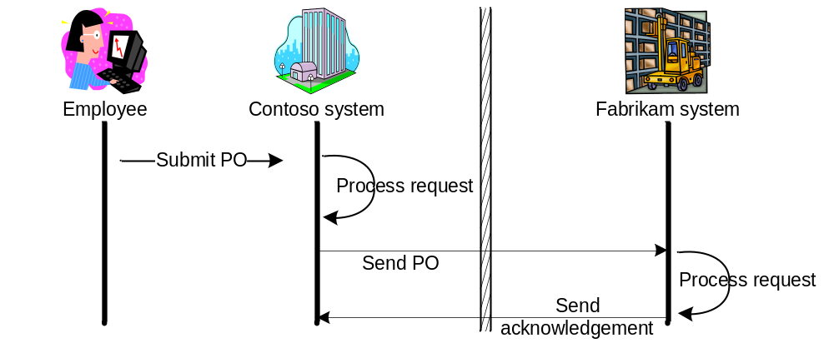

PO is accepted and will be fulfilled by Fabrikam or Northwind.

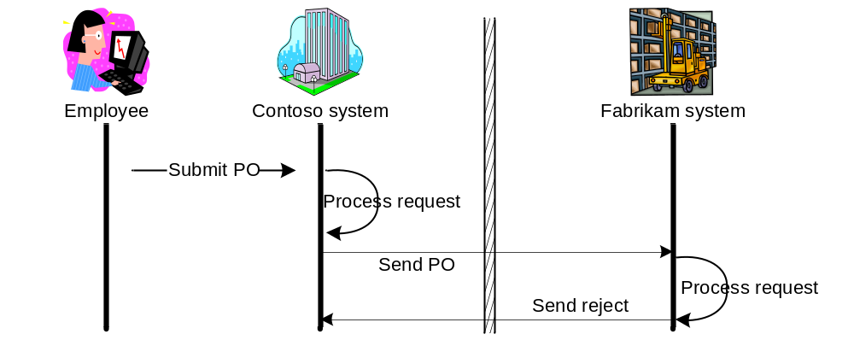

PO is accepted, but fulfiller will not be able to fulfill it.

Exercise 1 – Consuming Web Services
In this exercise, we will develop the workflow for the heart of Contoso’s system which processes the submitted PO’s and consumes a web service that exposes Fabrikam’s or Northwind’s PO processing service.
We will use a provided workflow host application and a web service that simulates the Fabrikam’s system.
Provided host application
PO processing workflow – Exercise code
Provided Fabrikam web service

Task 1 – Setup the Visual Studio solution
We will start with setting up the Visual Studio 2005 solution we will be using throughout the lab by copying the provided resources to the lab folder.

- Open Windows Explorer and navigate to C:\Windows Workflow Foundation\Labs\VB\Lab06\Resources
- Copy all of the contents of this folder, to C:\Windows Workflow Foundation\Labs\VB\Lab06
- Double click the Visual Studio solution file WebServices.sln to open Visual Studio 2005.
- Visual Studio 2005 opens with the solution and the following should be present in the Solution Explorer window:
Fabrikam Web Service
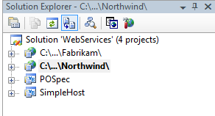
Northwind Web Service
Helper project which contains the PO schema
Workflow host application

Important: The Web Services projects in the lab use the ASP.NET Development Server with the Use Dynamic Ports property set to True other than the default setting False and specific values are set for the Port Number properties of the projects. The environment this lab is run may be different on different computers, where this assumption may not be correct. If you observe inconsistent behavior with the web services please try changing the Use Dynamic Ports setting and/or the Port Number properties as a step of your troubleshooting process. The Port Number property values for the Web Service projects are set to the following values:
Port Number property value for Fabrikam Web Service: “50557”
Port Number property value for Northwind Web Service: “50516”

- There are also completed versions of the exercises in the Exercise 1 and Exercise 2 folders under Completed. In order to run those exercises successfully, the ASP.NET Development Server instances have to be started. Please right-click on each of the Web Service projects in the solution and select View in Browser from the context menu to start the servers. Both exercises use two Web Services. If both of the servers are running, the flowing two icons should be in the Notification Area of the Taskbar:

Task 2 – Add the workflow project
The workflow project will create an assembly that contains the workflow model we will create. We will be using a sequential workflow.

- In Solution Explorer, select the solution node WebServices, open the context menu by right-clicking, and select Add | New Project.
- Visual Studio 2005 will display the Add New Project dialog window
- In the Add New Project dialog window, expand Visual Basic | Workflow in the Project Types tree on the left pane.
- Select Sequential Workflow Library from the templates list and rename the project as ContosoWorkflows and click OK.

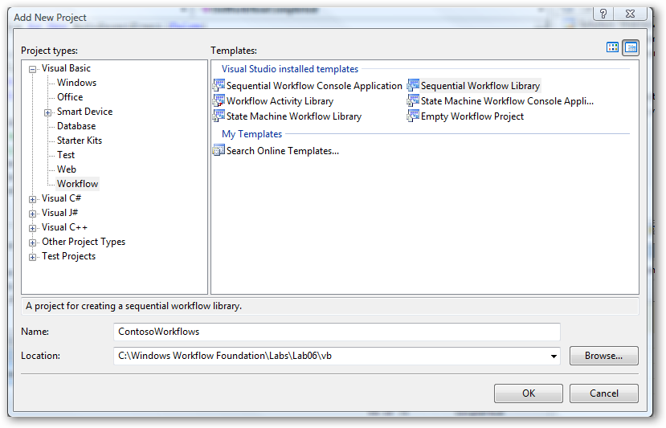

- Add a project reference to the POSpec helper project in ContosoWorkflows by right-clicking on the project in the Solution Explorer view and selecting the Add Reference menu item.

- Move the file named POHelpers.vb under C:\Windows Workflow Foundation\Labs\Lab06\Resources\VB\ to C:\Windows Workflow Foundation\Labs\Lab06\ ContosoWorkflows\VB
- Right-click on the ContosoWorkflows project in the Solution Explorer and select Add | Existing Item… and add the file POHelpers.vb to the project.
- Add the public member newPO to the workflow class by opening the processPOWorkflow.vb workflow. You can view the source code by right-clicking on the processPOWorkflow.vb design surface and selecting View Code menu item.

Public newPO As POSchema.PO = POSchema.PO.GeneratePOInstance()

- Compile the POSpec project by right clicking the project and selecting Build.

Task 3 – Add the workflow activities

- Switch to the designer view for the workflow processPOWorkflow.vb, by double clicking it on the Solution Explorer.
- Drag and drop an IfElse activity from the Toolbox to the Visual Studio workflow designer, just under the down-pointing green arrow.
- Change the Name property of the IfElse activity to checkOrderTotal.
- Rename the ifElseBranchActivity1 by selecting the decision branch and set the Name property to ifOrderSmallerThan1000.
- Select the condition type as Declarative Rule Condition from the dropdown list for the Condition property.
- Expand the Condition property node by clicking on the + sign and set the ConditionName property as ifOrderSmallerThan1000.
- Click on the Ellipsis button for the ConditionName property to display the Select Condition dialog box

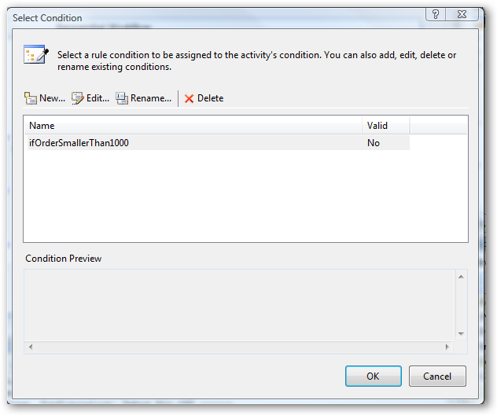

- Select the Edit Condition… button to set the expression. This will open the Rule Condition Editor

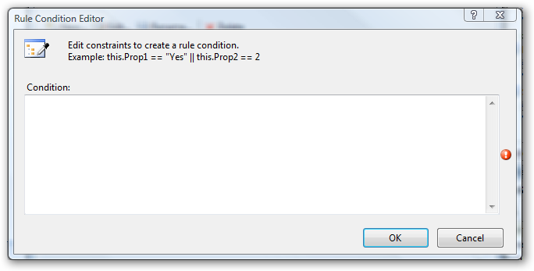

- Add the following line into the Rule Condition Editor:

this.newPO.OrderTotal <= 1000

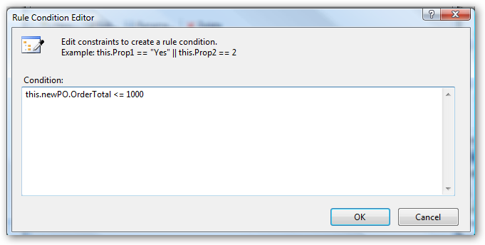

- Click OK twice to close the Select Rule Condition and Rule Condition Editor dialog boxes.
- Change the Name property of ifElseBranch2 to Else_.
- Right-click on the Fabrikam web service and select Build Web Site.
- Right-click on the Northwind web service and select Build Web Site.
- In the Solution Explorer, select the Service.asmx file in the Fabrikam web service project and right-click and select the View In Browser option in the context menu.
- Copy the URL in the address bar by using CTRL + C in the opened Internet Explorer. Please do not forget to close the browser to be able to view the web service in the next step.
- Make sure processPOWorkflow.vb is open by double clicking on it in Visual Studio 2005.
- Drag and drop an InvokeWebService activity to the ifOrderSmallerThan1000 branch. This will open the Add Web Reference dialog.
- Paste the URL you have copied before into the URL field and press Go button.
- Type in Fabrikam for the Web Reference Name text box.

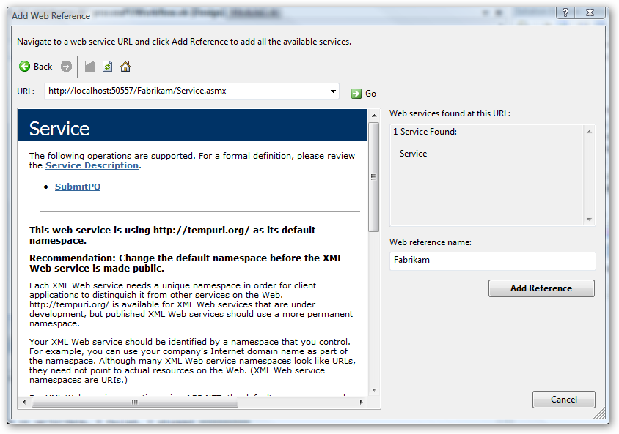

- Click on the Add Reference button to close the dialog box.
- Change the Name property of the InvokeWebService activity you have added to invokePOSubmissionWSFabrikam.
- Set the Method Name property of the invokePOSubmissionWSFabrikam activity by selecting SubmitPO from the dropdown list.
- For the incomingPO property of the activity click the ellipsis button to bring up the activity binding interface, select the Bind to a new member tab and enter outgoingPOforFabrikam as the New member name.

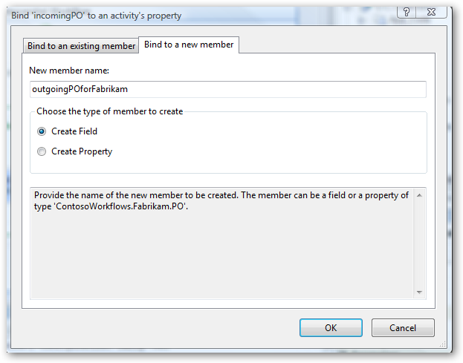

- Check the Create Field radio button and click OK.
- For the (ReturnValue) property of the activity click the ellipsis button again to bring up the activity binding interface, select the Bind to a new member tab and enter POResponsefromFabrikam as the New member name.

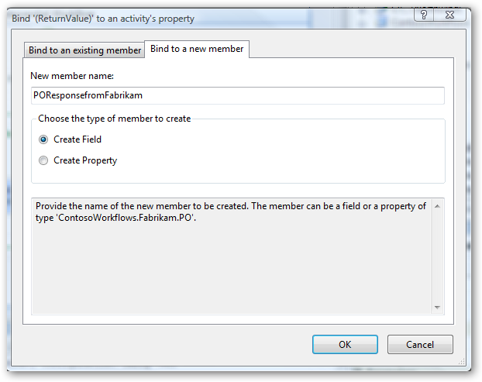

- Check the Create Field radio button and click OK.
- These steps will add the following code to processPOWorkflow.vb:

Public outgoingPOforFabrikam As New ContosoWorkflows.Fabrikam.PO
Public POResponsefromFabrikam As New ContosoWorkflows.Fabrikam.PO

- Open the designer view, right-click on the activity invokePOSubmissionWSFabrikam and select Generate Handlers….to generate the Invoking code handler. We will copy the data to be passed to the web service in this step later with the code we will insert.
- Switch to the design view again, drag and drop a Code activity from the Toolbox after the invokePOSubmissionWSFabrikam activity in the ifOrderSmallerThan1000 branch and change its Name to afterWSFabrikamInvoke.
- In the Solution Explorer, select the Service.asmx file in the Northwind web service project and right-click and select the View In Browser option in the context menu.
- Copy the URL in the address bar by using CTRL + C in the opened Internet Explorer. Please do not forget to close the browser to be able to view the web service in the next step.
- Add another InvokeWebService for the Else branch
- Repeat steps 15-28 for adding the invoke web service activity for Northwind. Use the following values for the activity’s properties
  - Paste the URL as described in step 15.
  - For step 19, use Northwind for the Web Reference Name
  - For step 21, use invokePOSubmissionWSNorthwind as the activity’s Name.
  - For step 22, use SubmitPO as the activity’s Method Name
  - For step 23, use outgoingPOforNorthwind
  - For step 25, use POResponsefromNorthwind
  - Open the designer view, right-click on the activity invokePOSubmissionWSNorthwind and select Generate Handlers….to generate the Invoking code handler. We will copy the data to be passed to the web service in this step later with the code we will insert
- Switch to design view again, add another Code activity from the Toolbox after the invokePOSubmissionWSNorthwind and change the Name property to afterWSNorthwindInvoke. Double click on the Code activities to generate their code handlers.
- The resulting workflow should look like this:

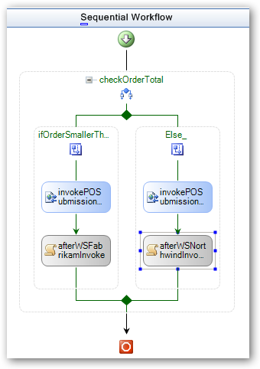

- If you are seeing red exclamation marks on the Code activities, that means the code handlers have not been not generated yet. Double-click on the Code activities to generate their code handlers.
- Insert the code snippets specified in Table 1: Code handlers and snippets mapping by right-clicking in the code handlers and selecting Insert Snippet… navigate to the snippet you want and insert by double-clicking on My Code Snippets then open the Lab06 snippets.

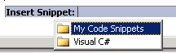

Note: If you do not see the Code Snippet in the list, then please make sure the code snippet files have been copied to the appropriate directory and have been added to the Code Snippets Manager (Tools | Code Snippets Manager)
Table 1: Code handlers and snippets mapping
Code handler | Snippet Name
invokePOSubmissionWSNorthwind_Invoking | Lab06 Ex01 Task03 invokePOWSNorthwind
invokePOSubmissionWSFabrikam_Invoking | Lab06 Ex01 Task03 invokePOWSFabrikam
afterWSFabrikamInvoke_ExecuteCode | Lab06 Ex01 Task03 afterWSFabrikamEx
afterWSNorthwindInvoke_ExecuteCode | Lab06 Ex01 Task03 afterWSNorthwindEx

If you have created the member variables with different names during the previous steps, please make sure to modify the code snippets accordingly.

invokePOSubmissionWSNorthwind_Invoking

POHelpers.CopyPOHeader(newPO, outgoingPOforNorthwind)
POHelpers.CopyPOHistory(newPO, outgoingPOforNorthwind)
POHelpers.CopyPOItems(newPO, outgoingPOforNorthwind)

invokePOSubmissionWSFabrikam_Invoking

POHelpers.CopyPOHeader(newPO, outgoingPOforFabrikam)
POHelpers.CopyPOHistory(newPO, outgoingPOforFabrikam)
POHelpers.CopyPOItems(newPO, outgoingPOforFabrikam)

afterWSNorthwindInvoke_ExecuteCode

'Initialize it to a time where electronic PO processing was not
‘invented.

Dim statusDate As New DateTime(1900, 1, 1)
Dim lastStatus As Northwind.POStatus = Nothing

'Find the last status by looping over the history items
For Each stat As Northwind.POStatus In _
POResponsefromNorthwind.History

If (stat.Timestamp > statusDate) Then

statusDate = stat.Timestamp
lastStatus = stat
End If

Next
System.Console.WriteLine("Your PO has been {0} on {1} by Northwind", _
lastStatus.PoStatus, lastStatus.Timestamp)

afterWSFabrikamInvoke_ExecuteCode

'Initialize it to a time where electronic PO processing was not
‘invented.
Dim statusDate As New DateTime(1900, 1, 1)
Dim lastStatus As Fabrikam.POStatus = Nothing

'Find the last status by looping over the history items
For Each stat As Fabrikam.POStatus In POResponsefromFabrikam.History

If (stat.Timestamp > statusDate) Then

statusDate = stat.Timestamp
lastStatus = stat
End If

Next
System.Console.WriteLine("Your PO has been {0} on {1} by Fabrikam", _
lastStatus.PoStatus, lastStatus.Timestamp)

Note: The code snippets you have just inserted convert between two different data types of PO for the internal Contoso system and the PO type exposed by the web service. The schema for the two PO types is the same though.

Task 4 – Configure your host to use the ContosoWorkflows

- Right-click on the SimpleHost project in the Solution Explorer and add a project reference to ContosoWorkflows project (your newly created Workflow project)
- Open the file Module1.vb by double-clicking on it in the solution explorer.
- Make sure that you can view the Tasks List window in Visual Studio 2005 by selecting View | Task List (or by CTRL+\, CTRL+T)
- Select Comments from the drop down box in the Task List (default view is User Tasks) to view the places you will be making modifications in the SimpleHost project code.
- Double click on the task that reads TODO: Add 2 lines to the code similar to the 2 below
- Add the code lines as shown to specify the workflow type you will use.

Dim wType As Type = GetType(ContosoWorkflows.processPOWorkflow)
workflowRuntime.CreateWorkflow(wType).start()

Task 5 – Building and running the project

- Right-click and select Build Solution on the WebServices solution node in the Solution Explorer or press CTRL+SHIFT+B to rebuild the whole solution.
- Right-click on the SimpleHost project and select Set as StartUp Project

Note: If the solution does not run, please check whether the port numbers for the web services are the same as the ones in the web references for the invoke web service activities in the workflow.

- Press CTRL+F5 to run the SimpleHost. The output should be like the following in a console window.

Your PO has been Accepted on 2/4/2005 6:21:25 PM by Fabrikam

Press Enter to continue...

- Press ENTER twice to close the console window.

Exercise 2 – Exposing Web Services

We will build on our previous work for this exercise, replacing the Fabrikam web service with a new workflow.

Provided host application
PO processing workflow – from Exercise 1
Fabrikam web service will be replaced
Exercise 2 structure

Task 1 – Setting up the project
- If the solution from the previous exercise is not open, open it now.
- Right-click on the Fabrikam web service in the Solution Explorer and select Remove.

Task 2 – Adding the Fabrikam workflow project

- In Solution Explorer, select the WebServices solution node, and open the context menu by right-clicking, and select Add | New Project.
- Visual Studio 2005 will display the Add New Project dialog window
- In the Add New Project dialog window, expand Visual Basic | Workflow in the Project Types tree on the left pane.
- Select Sequential Workflow Library from the templates list and rename the project as FabrikamWorkflows.
- Add a reference to project POSpec in the newly created project.
- Rename the Workflow1.vb workflow to processPOWorkflow.vb by right-clicking on it in the Solution Explorer and selecting Rename.

Task 3 – Authoring the Fabrikam workflow project

- Open processPOWorkflow.vb workflow by double clicking it.
- Right-click on the design surface and select View Code
- Add the following interface definition to the namespace:

(Snippet: “Lab06 Ex02 InterfaceDefinition”)
'Webservice interface definition for the workflow
Public Interface IProcessReceivedPO

Function ReceiveAndProcessPO(ByVal aPO As POSchema.PO) As POSchema.PO

End Interface

- This interface defines the interface for the workflow to be exposed as a web service.
- Switch to the design view by double-clicking on the processPOWorkflow.vb. Drag a WebServiceInput activity from the Toolbox and drop it just under the down-pointing green arrow on the design surface. Change its Name property to webServiceReceivePO.
- Drag and drop a WebServiceOutput activity from the Toolbox below the webServiceReceivePO activity and change the Name property to webServiceResponsePO.
- Set the Interface Type property of the webServiceReceivePO activity to FabrikamWorkflows.IProcessReceivedPO by clicking on the Ellipsis button in the property value box and selecting the interface from the type picker dialog box.

- Select the webServiceReceivePO activity and set the activity properties as follows:
  - IsActivating: True
  - MethodName: ReceiveAndProcessPO
- For the aPO property, click the ellipsis to open the activity binding interface and bind aPO to a new field member named receivedPO.
- Select the webServiceResponsePO activity and set the InputActivityName to webServiceReceivePO.
- For the (ReturnValue) property, click the ellipsis to open the activity binding interface and bind (ReturnValue) to a new field member named returnedPO.
- Right click on the webServiceResponsePO and select Generate Handlers… to add the SendingOutput code handler.
- Add the following code to the webServiceResponsePO_SendingOutput code handler.

(Snippet: “Lab06 Exercise02 Task03 webServiceResponsePO”)
POSchema.PO.GenerateResponseHeader(receivedPO, returnedPO, "Fabrikam_")
POSchema.PO.CopyHistoryAndChangeStatus(receivedPO, returnedPO, "Accepted")
POSchema.PO.CopyPOItems(receivedPO, returnedPO)

Note: It is extremely important to have defined responsePO and receviedPO exactly as they were described in the previous steps, as this code assumes those members exist.
- The resulting workflow should look like this:

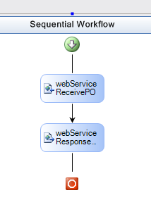

Task 4 – Publishing the workflow as a web service
- Build the solution to make sure that it compiles successfully
- Right-click on the FabrikamWorkflows project in the Solution Explorer and select Publish as web service
- Observe that this action created a new project in the same solution with the name FabrikamWorkflows_WebService
- This action will cause the following to occur:
  - Creation of an .asmx file that specifies a web service deriving from FabrikamWorkflows.processPOWorkflow_WebService

<%@WebService Class="FabrikamWorkflows.processPOWorkflow_WebService" %>

  - Modification of the HTTPPipeline for the service for hosting workflows and running them

<httpModules>
<add type="System.Workflow.Runtime.Hosting.WorkflowWebHostingModule, System.Workflow.Runtime, Version=3.0.00000.0, Culture=neutral, PublicKeyToken=31bf3856ad364e35" name="WorkflowHost"/>
</httpModules>

  - Out-of-box pluggable runtime services configuration in the web.config file

<configSections>
<section name="WorkflowRuntime" type="System.Workflow.Runtime.Configuration.WorkflowRuntimeSection, System.Workflow.Runtime, Version=3.0.00000.0, Culture=neutral, PublicKeyToken=31bf3856ad364e35" />
</configSections>

<WorkflowRuntime Name="WorkflowServiceContainer" >
<Services>
<add type="System.Workflow.Runtime.ManualWorkflowSchedulerService, System.Workflow.Runtime, Version=3.0.00000.0, Culture=neutral, PublicKeyToken=31bf3856ad364e35” />
<add type="System.Workflow.Runtime.Hosting.DefaultWorkflowTransactionService, System.Workflow.Runtime, Version=3.0.00000.0, Culture=neutral, PublicKeyToken=31bf3856ad364e35" />
</Services>
</WorkflowRuntime>

- This Lab uses fixed port numbers for the Web Services. Please set the Use Dynamic Ports property of the newly generated Web Service project to False and set the Port Number to “4487”.
Note: If you observe inconsistent behavior with the Web Services, changing the “Use Dynamic Ports” property value to “True” can be one of the troubleshooting steps, as the port assignment assumptions of this lab may be conflicting with the environment.

Task 5 – Accessing the published workflow

- If a browser displaying a web service from a previous step is still open, close the browser first. Right-click on the newly generated web service (.asmx file) and select View in Browser. Click on the .asmx resource in the browser and copy the URL string in the Address Bar of the browser using CTRL+C.
- Open the processPOWorkflow.vb of the ContosoWorkflows project by double-clicking it in the Solution Explorer.
- Delete the Web Reference name Fabrikam from the ContosoWorkflows project, by extending the Web References node of the project, selecting the Web reference Fabrikam, right clicking on it and selecting Delete from the context menu.
- Delete invokePOSubmissionWSFabrikam by selecting it and right clicking then selecting Delete.
- Drag an InvokeWebService activity from the Toolbox to the position invokePOSubmissionWSFabrikam previously held.
- Paste the URL string you have copied in step 1 into the URL text box in the Web Reference box and press Go button. Set the Web Reference Name to Fabrikam. Press the Add Reference button to update the web reference.
- Change the Name property to invokePOSubmissionWSFabrikam
- Change the following properties with the provided values
  - ProxyClass: ContosoWorkflows.Fabrikam.processPOWorkflow_WebService
  - Method: ReceiveAndProcessPO
- For the (ReturnValue) property, click the ellipsis to open the activity binding interface and bind (ReturnValue) to the existing field member named POResponsefromFabrikam.
- For the aPO property, click the ellipsis to open the activity binding interface and bind aPO to the existing field member named outgoingPOforFabrikam.
- In the Properties panel click the Events button. This will display the Invoked and Invoking handlers. Set the following:

Invoked: invokePOSubmissionWSFabrikam_Invoked

Invoking: invokePOSubmissionWSFabrikam_Invoking

- Delete the Web Reference Name Northwind from the ContosoWorkflows project, by extending the Web References node of the project, selecting the Web reference Northwind, right clicking on it and selecting Delete from the context menu.
- In the Solution Explorer, select the Service.asmx file in the Northwind web service project and right-click and select the View In Browser option in the context menu.
- Copy the URL in the Address Bar by using CTRL + C in the opened Internet Explorer. Please do not forget to close the browser to be able to view the web service in the next step.
- Right click the ContosoWorkflows project and select Add WebReference.
- Paste the URL string you have copied in step 14 into the URL text box in the Web Reference box and press Go button. Set the Web Reference Name to Northwind. Press the Add Reference button to update the web reference.
NOTE: The following additional steps may be necessary because removing the Northwind web service reference sometimes clears these settings:
- Select invokePOSubmissionWSNorthwind
- Set the following properties:
  - ProxyClass: ContosoWorkflows.Northwind.Service
  - MethodName: SubmitPO
  - (ReturnValue): POResponsefromNorthwind
  - incomingPO: outgoingPOforNorthwind

Task 6 – Compiling and running the project

- Build the solution as described in of Exercise 1 at step 1.
- Press CTRL+F5 to run the solution (please make sure that SimpleHost project is set up as StartUp project)
- You should be able to see the same result as in Exercise 1.
- Press ENTER twice to close the console window

Lab Summary
The objective of this lab was to introduce consuming web services from the workflows and exposing them as web services. Using Web Services is one of the mechanisms to communicate with the external applications from within the workflows. We completed two exercises;
- The first one was consuming two web services. Contoso had a simple policy, if the PO total is larger than $1000 it would fulfill the PO through Northwind, otherwise, it is always Fabrikam. The PO gets submitted to the corresponding web service from within the workflow.
- We changed the implementation of Fabrikam’s web service during the second exercise with a workflow. We then expose Fabrikam’s workflow which implements the business logic as a web service to be consumed from within Contoso’s workflow.

